Signal Description: ______________________________- Node ID: _____._____._____.______.______._____
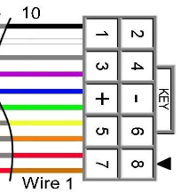
Signal Mast Designation: _________________________ Mast Head(s) Used: ________________
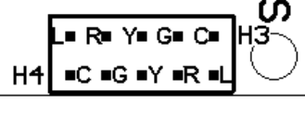
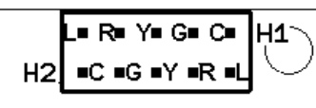
H1: 1 Com ____ H2: 2 L ___ H3: 1 Com ____ H4: 2 L ___
3 G ____ 4 R ___ 3 G ____ 4 R ___
5 Y ____ 6 Y ___ 5 Y ____ 6 Y ___
7 R ____ 8 G ___ 7 R ____ 8 G ___
9 L ____ 10 Com ___ 9 L ____ 10 Com ___
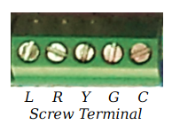
Note: Connector Pin Numbers are OPPOSITE of Cable Wire numbers. Wire 1 is red.
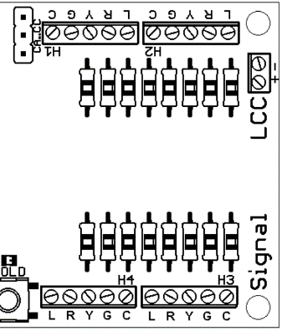
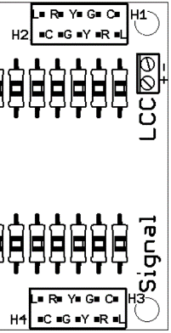
Signal-LCC-P Signal-LCC-S I/O Wiring:
Connection Connector Wire No Layout
Name Pin # Ref
Line 1 10 1 ________________________________ color __ __
Line 2 9 2 ________________________________ __ __
Line 3 8 3 ________________________________ __ __
Line 4 7 4 ________________________________ __ __
+5 VDC 6 5 ________________________________ R
Ground 5 6 ________________________________ B
Line 1 Line 5 4 7 ________________________________ __ __
Line 6 3 8 ________________________________ __ __
Line 7 2 9 ________________________________ __ __
Line 8 1 10 ________________________________ __ __

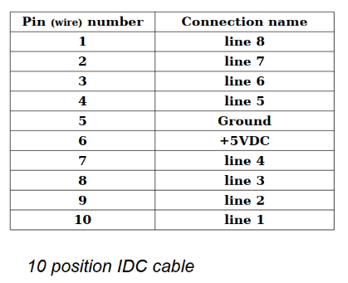
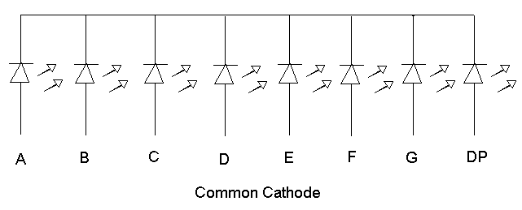
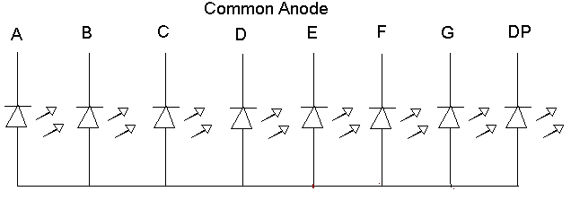
I/O-1 Connector Wiring Common Anode: Common Cathode:

